|  |  |  |
| --- | --- | --- |
| OOP Lab-04 Manual | March 27  2021 | |
| Name : Armghan Ahmad  Roll no,: 20p-0183  Section : BSCS 2B | | OOP LAB Assignment |

FUNCTIONS

**Question 1**

#include<iostream>

using namespace std;

// declaring a function

void greet(){

cout<<"Hello world!";

}

int main()

{

// calling a function

greet();

return 0;

}

Output:

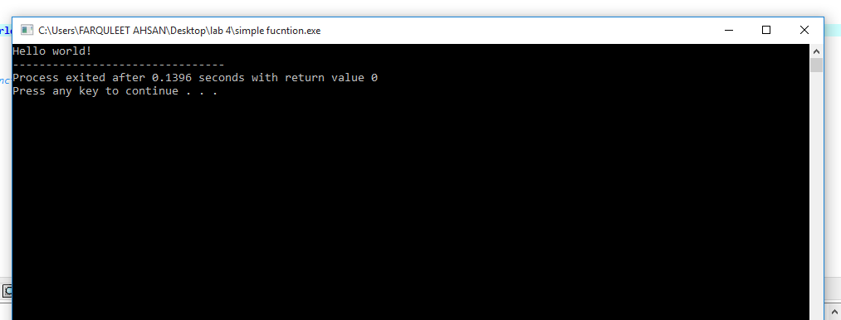

**Question 2 :**

#include<iostream>

using namespace std;

voidfunc()

{

staticinti=0;

int j=0;

i++;

j++;

cout<<"i="<<i<< "and j=0"<<j<<endl;

}

int main()

{

func();

func();

func();

return 0;

}

Output:

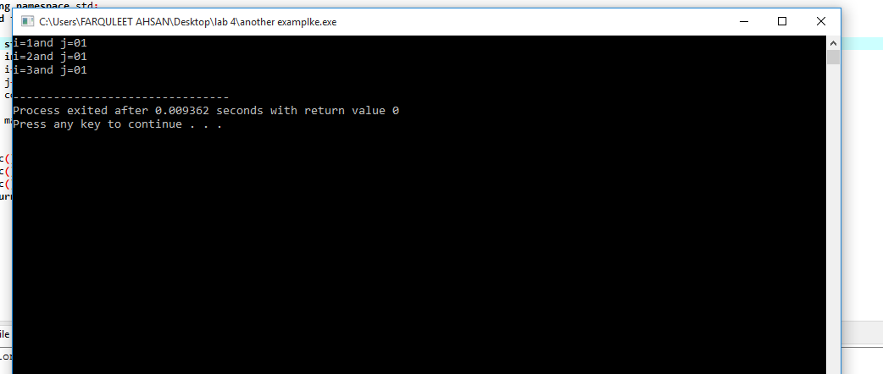

**Question 3:**

**#include<iostream>**

**using namespace std;**

**int add(int a, int b){**

**return (a + b);**

**}**

**int main(){**

**int sum;**

**sum=add(123, 45);**

**cout<<"123+45="<<sum<<endl;**

**return 0;**

**}**

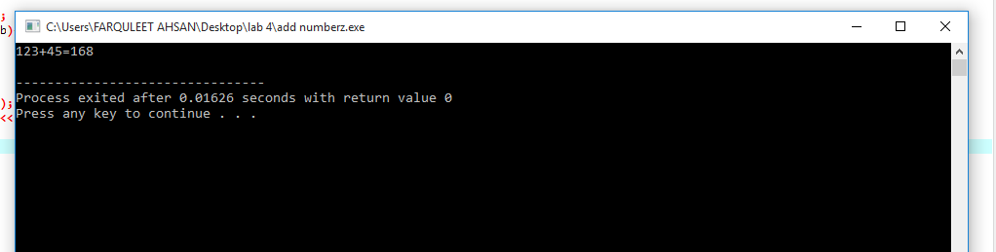

**Question 4:**

#include<iostream>

using namespace std;

int max(int num1, int num2);

int main(){

int a= 45;

int b= 65;

int ret;

ret = max(a, b);

cout<< "max value is:"<< ret <<endl;

return 0;

}

int max(int num1, int num2){

int result;

if(num1>num2)

result = num1;

else

result= num2;

return result;

}

Output:

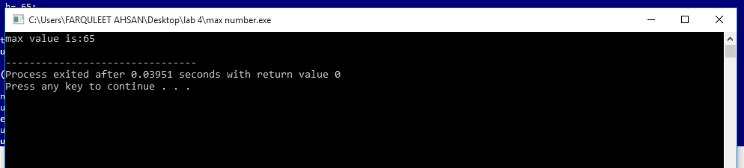

**Question 5:**

#include <iostream>

#include<math.h>

using namespace std;

int main()

{

intnum;

float result;

cout<<"Enter number: ";

cin>>num;

result = pow(num,0.5);

cout<< "Square root of given number is " << result;

return 0;

}

Output:

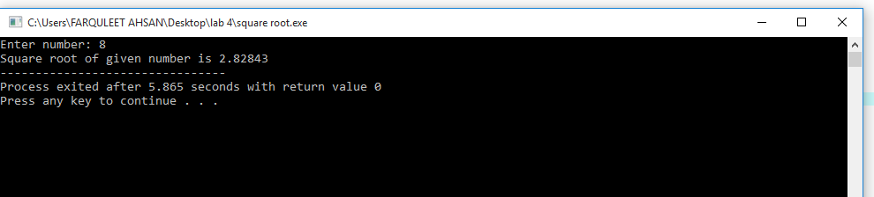

**Question 6:**

#include<iostream>

using namespace std;

int main()

{

// declare variables

double num1, num2;

// take input from end-user

cout<< "Enter two Numbers :: ";

cin>> num1 >> num2;

// addition of two number

cout<< num1 << "+" << num2 << " = "<< num1+num2 <<endl;

// subtraction of two number

cout<< num1 << "-" << num2 << " = "<< num1-num2 <<endl;

// multiplication of two number

cout<< num1 << "*" << num2 << " = "<< num1*num2 <<endl;

// division of two number

cout<< num1 << "/" << num2 << " = "<< num1/num2 <<endl;

return 0;

}

Output:

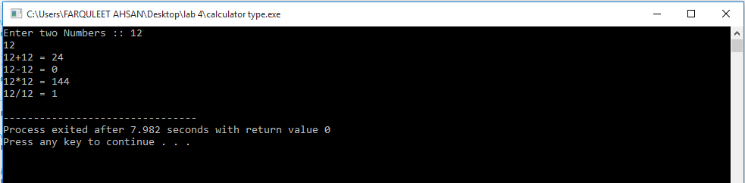

ARRAYS

**Questuion 1 a:**

**#include<iostream>**

**using namespace std;**

**int main()**

**{**

**int M[10], j;**

**M[0]= 2;**

**M[1]= 4;**

**M[2]= 6;**

**M[3]= 8;**

**M[4]= 10;**

**M[5]= 12;**

**M[6]= 14;**

**cout<<"Print all the numbers: \n";**

**for(j = 0; j< 7; ++j)**

**cout<<"M ["<<j <<"] = "<<M[j]<<endl;**

**cout<<"\n From End to beginning : \n";**

**for (j = 6; j >= 0; --j)**

**cout<<"M ["<<j <<"] = "<<M[j]<<endl;**

**return 0;**

**}**

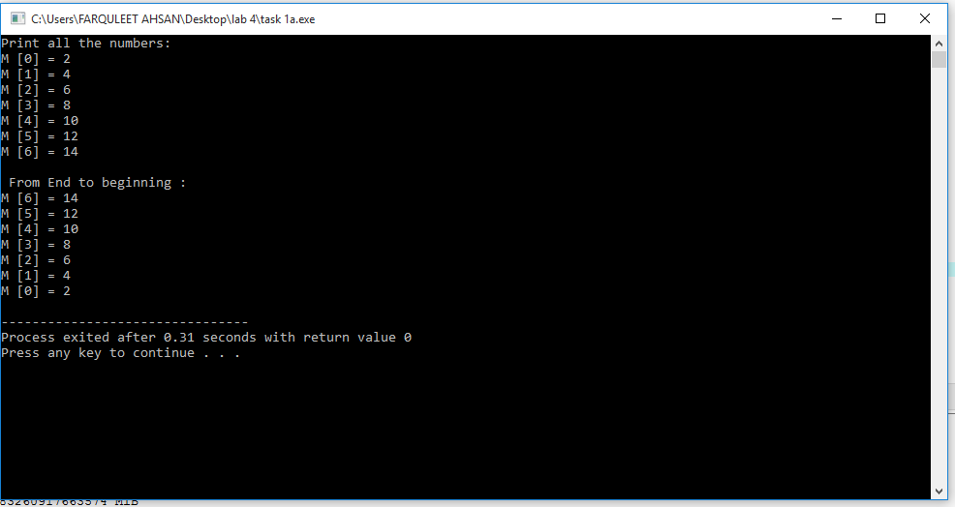

**Question 1 b:**

**#include<iostream>**

**#include<string>**

**using namespace std;**

**int main(){**

**string cars[4] = {"volvo" ,"BMW","Ford","mazda"};**

**cout<< cars[0];**

**return 0;**

**}**

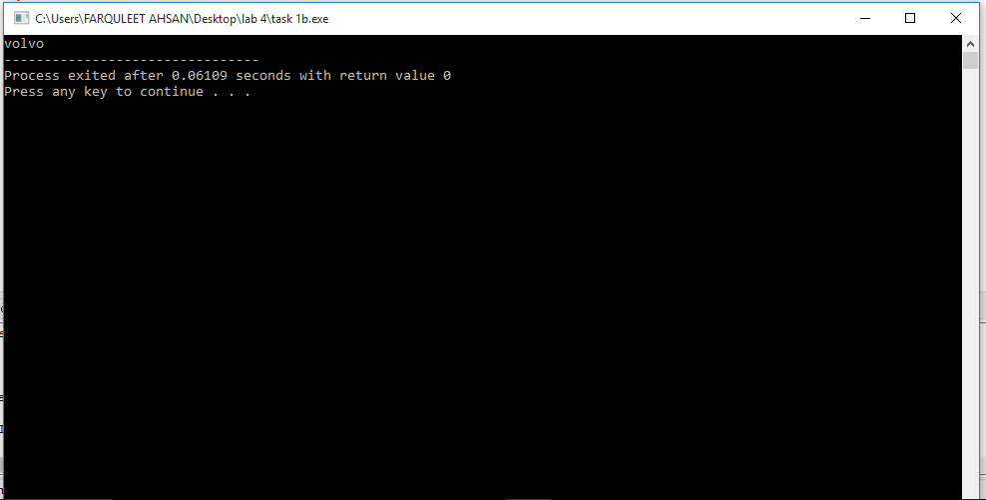

**Question 2:**

**#include<iostream>**

**using namespace std;**

**int main(){**

**string cars[4] = {"volvo" ,"BMW","Ford","mazda"};**

**for(inti = 0; i<4; i++){**

**cout<< cars[i]<< "\n";**

**}**

**return 0;**

**}**

